Student’s name | …………………………………………………….…… | Grade | 2
Subject | Computer | Week No. | 3
Lesson Title | Photo Gallery | Unit
Worksheet No. ( 3 )

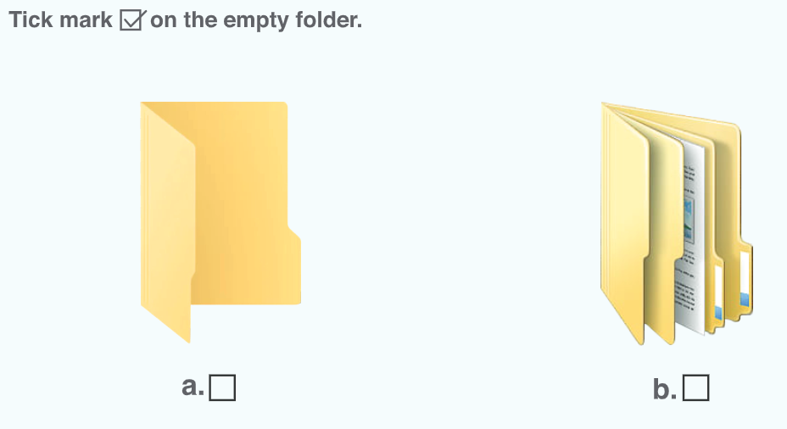
Good Luck

